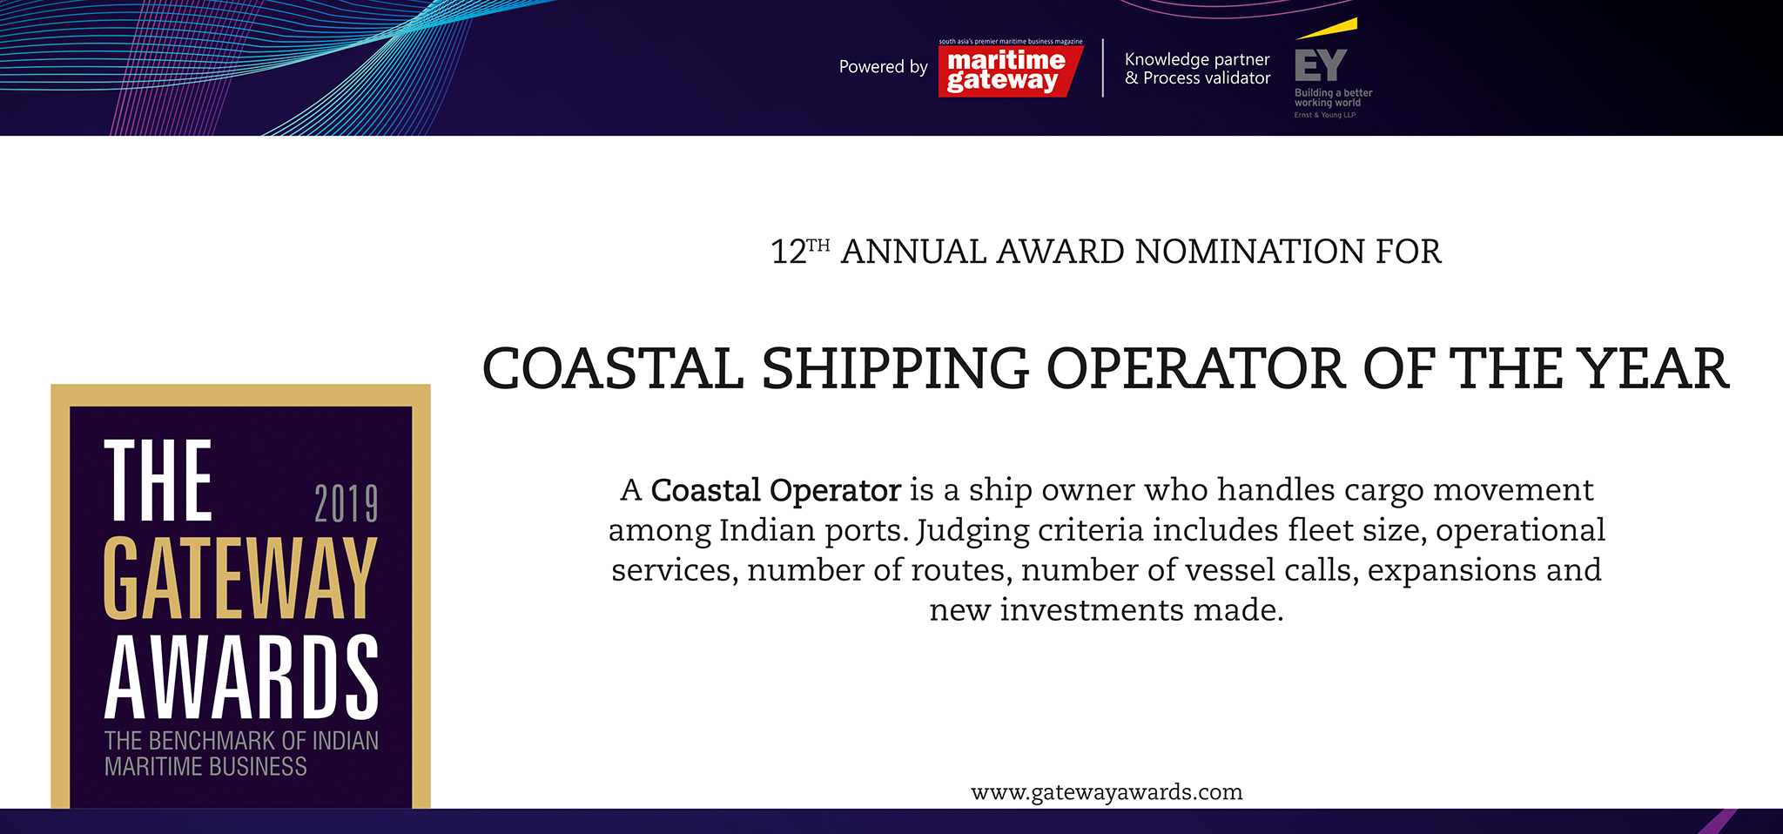

Please fill your responses and mail it to the address mentioned at the end of the Questionnaire

Note: All information and data should be provided for the FY 2018-19. In case, if you are unable to provide FY 2018-19 data, CY2018 information can be sent with a reason for not providing data for FY 2018-19.

Contact information:
Name of the Organization

Contact Person

Designation

Contact no.

Official Email ID

Address

Performance Indicators

Parameters | Units | Inputs
Total no. of Ships | Number
Total Tonnage | Gross Tonnage
Ships Operating on Indian Coast | Number
Non-containerized cargo handled | Million Tonnes
Containerized cargo handled | TEUs

Efficiency Indicators

Parameters |  | Units | Inputs
Y-O-Y Growth in non - Containerized cargo |  | Percent
Y-O-Y Growth in - Containerized cargo |  | Percent
Existing Services |  | Name of the Services
Coverage of ports on Indian coast |  | Port Names

Infrastructure Enhancements

Parameters | Type of inputs needed | Inputs
Fleet Addition | Number
 | Type of vessel
 | Capacity
New Services added | Service Name ( ex: CIX  express)
 | Port callings

Innovations/ Investments/ Enhancements

Parameters | Type of inputs needed | Inputs
Innovations | • Qualitative inputs  • Word limit ~ 200 words.
Business Processes
Efficiency
Technology
Investments made

Please use below contact for sending filled-in form and also for any queries.

Rakesh Oruganti | Cell: +91 99483 34568;E mail ID: rakesh.oruganti@gatewaymedia.in

